**1.(i)TABLEAU BAR CHART**

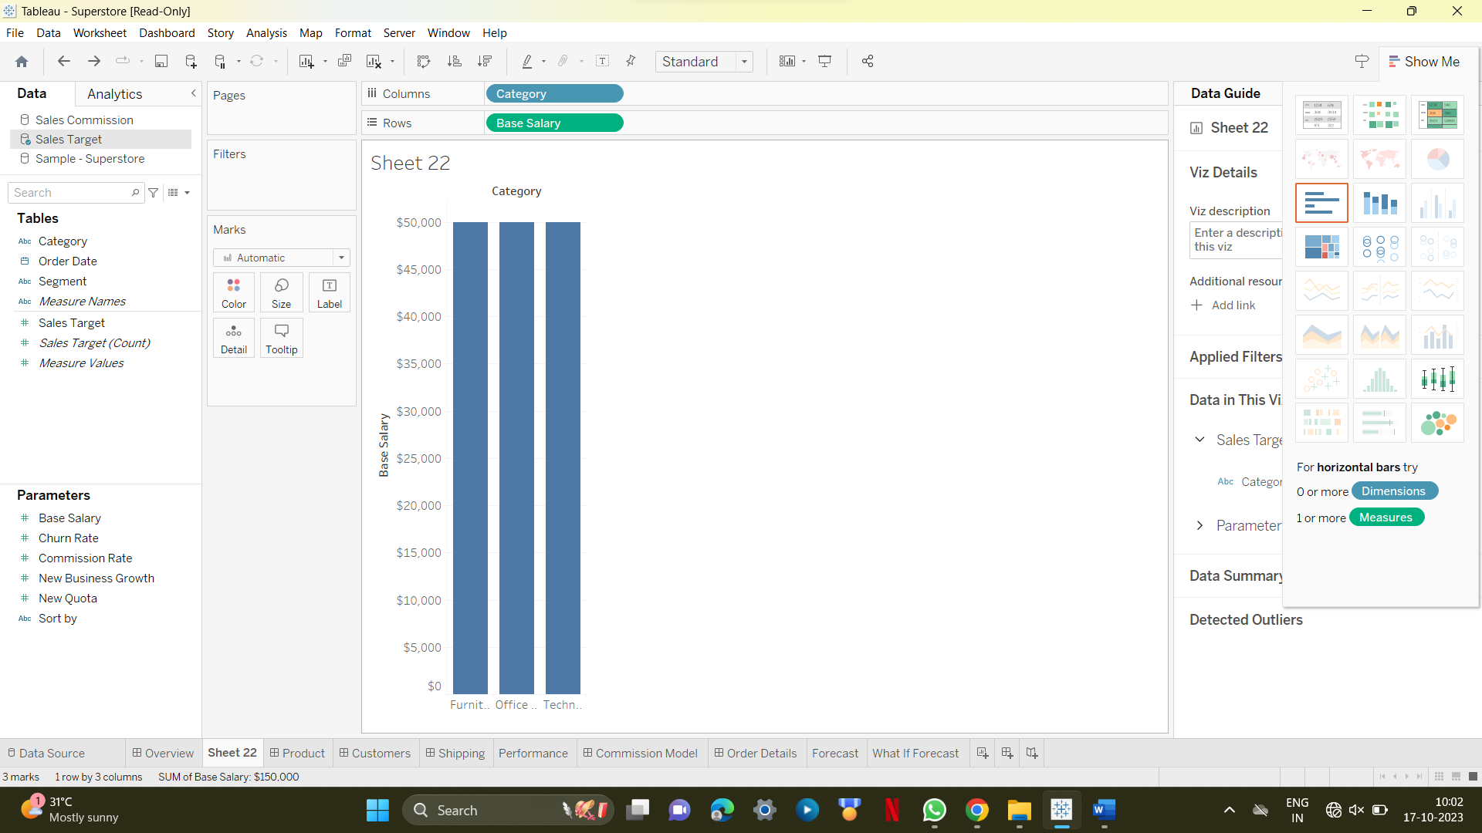

**1.(ii) Bar Chart with Color Range**

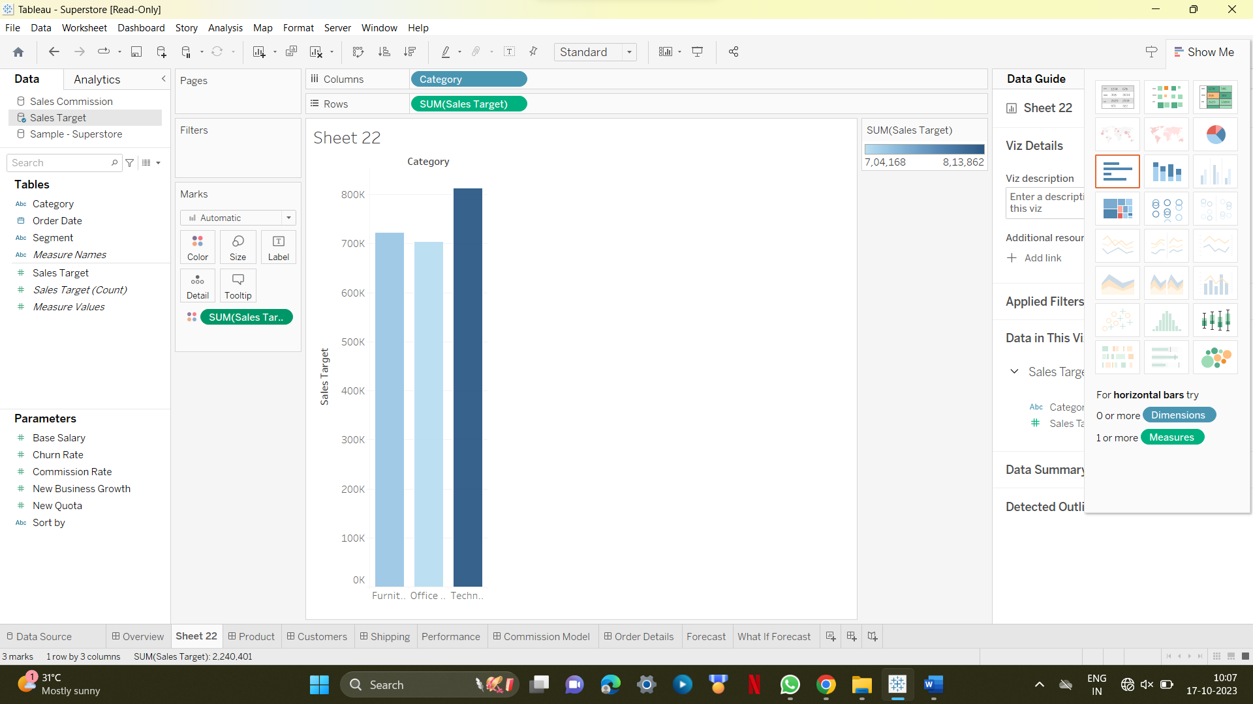

**1.(iii) Stacked Bar Chart**

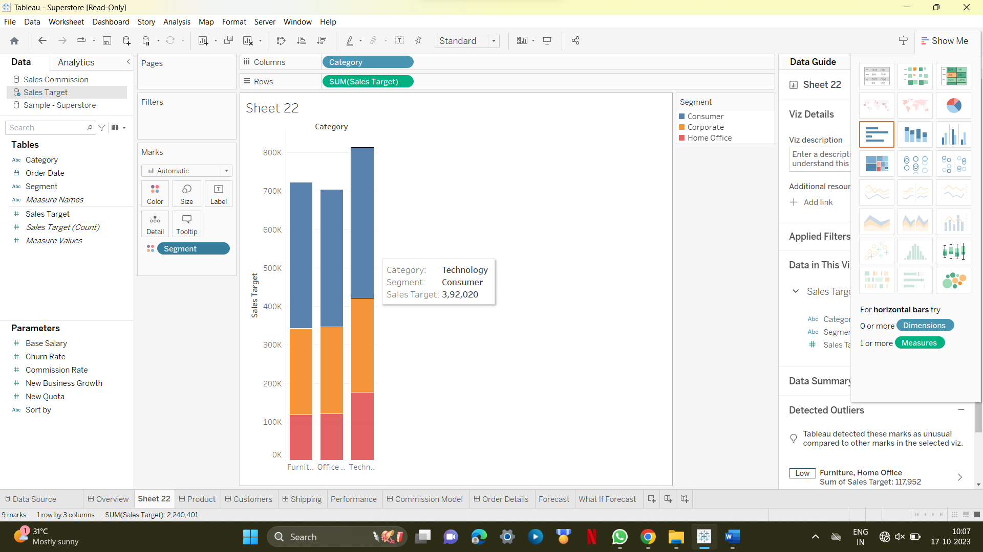

**2.(ii)Tableau line chart**

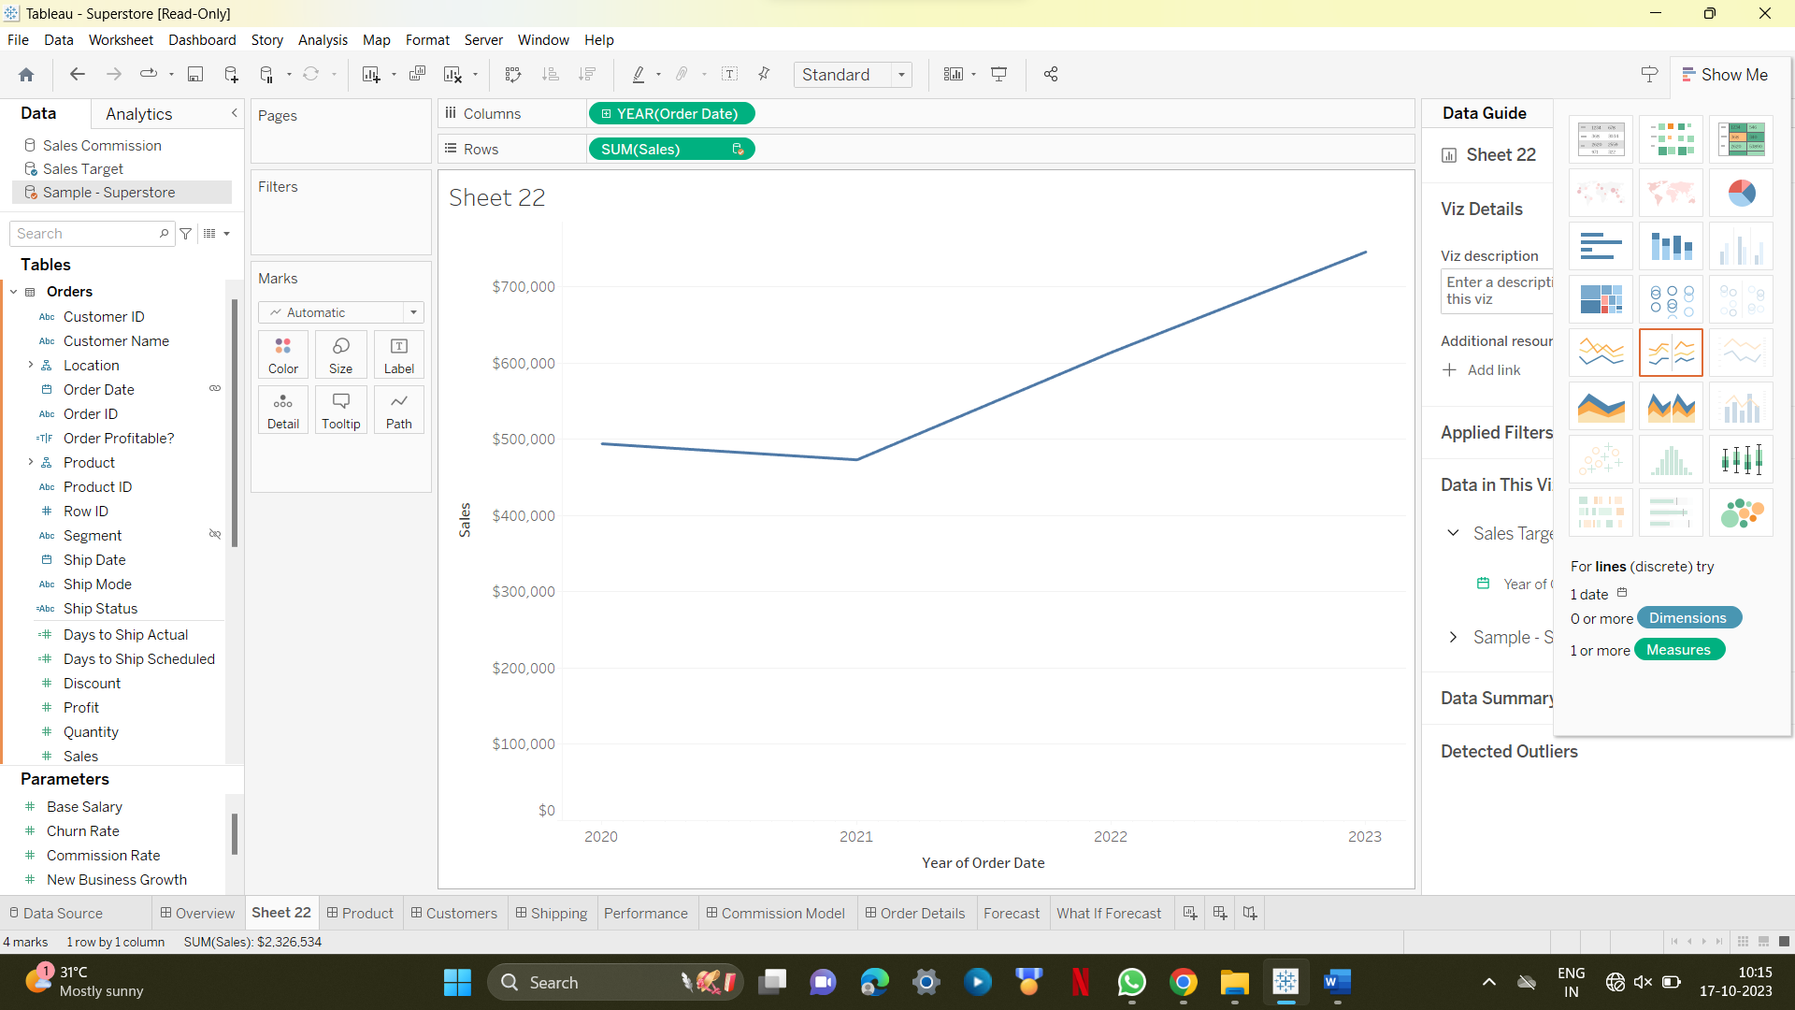

**2.(ii)Multiple line chart**

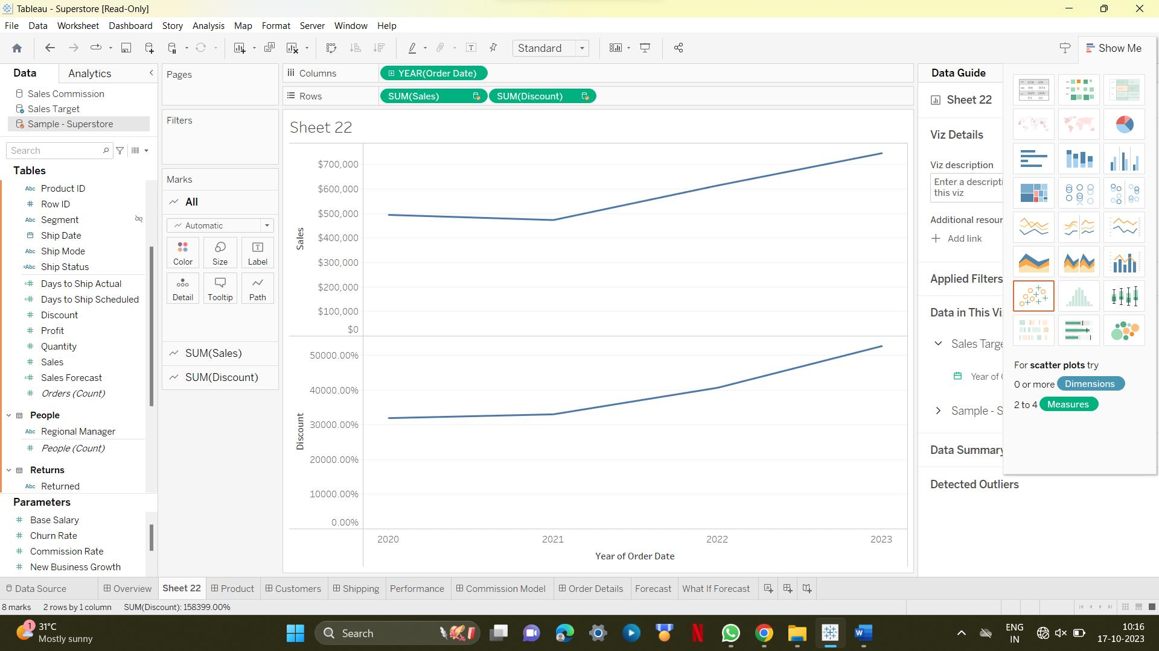

**2.(iii)Line chart with labels**

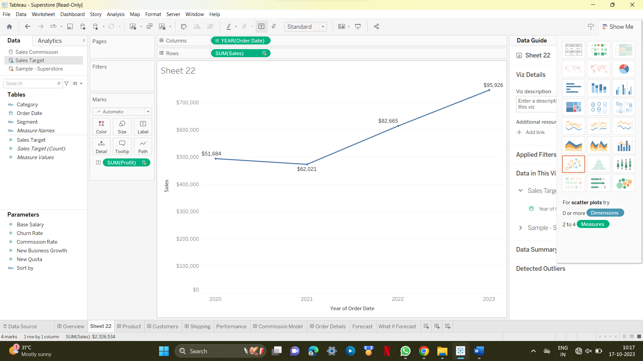

**3.(i)Tableau pie chart**

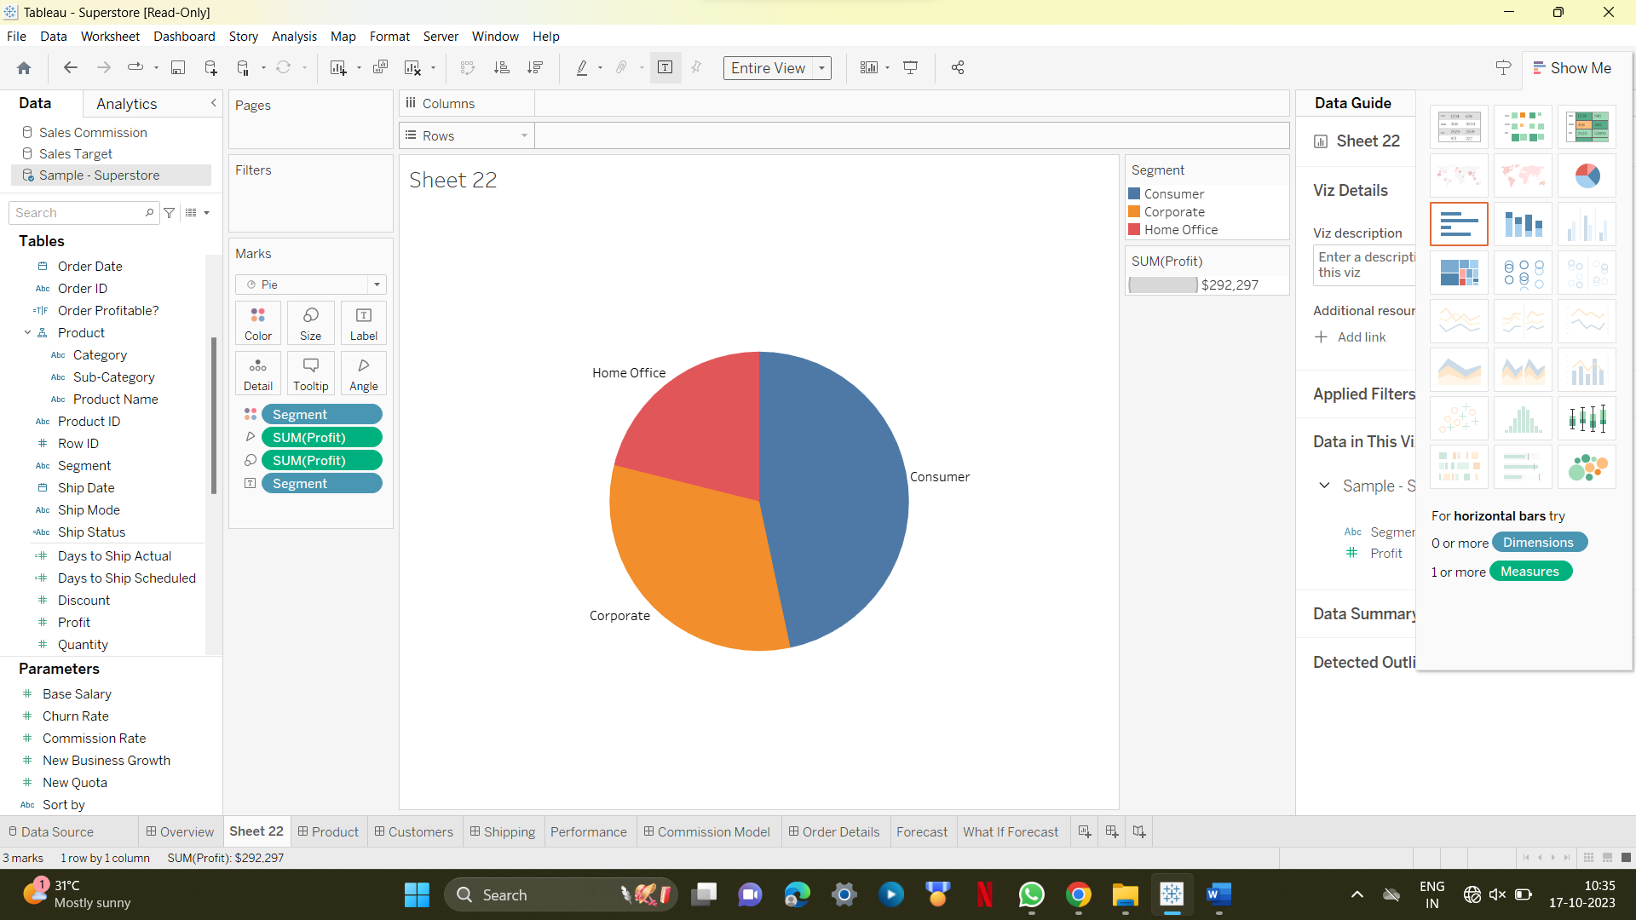

**3.(ii) Drill Down Pie Chart**

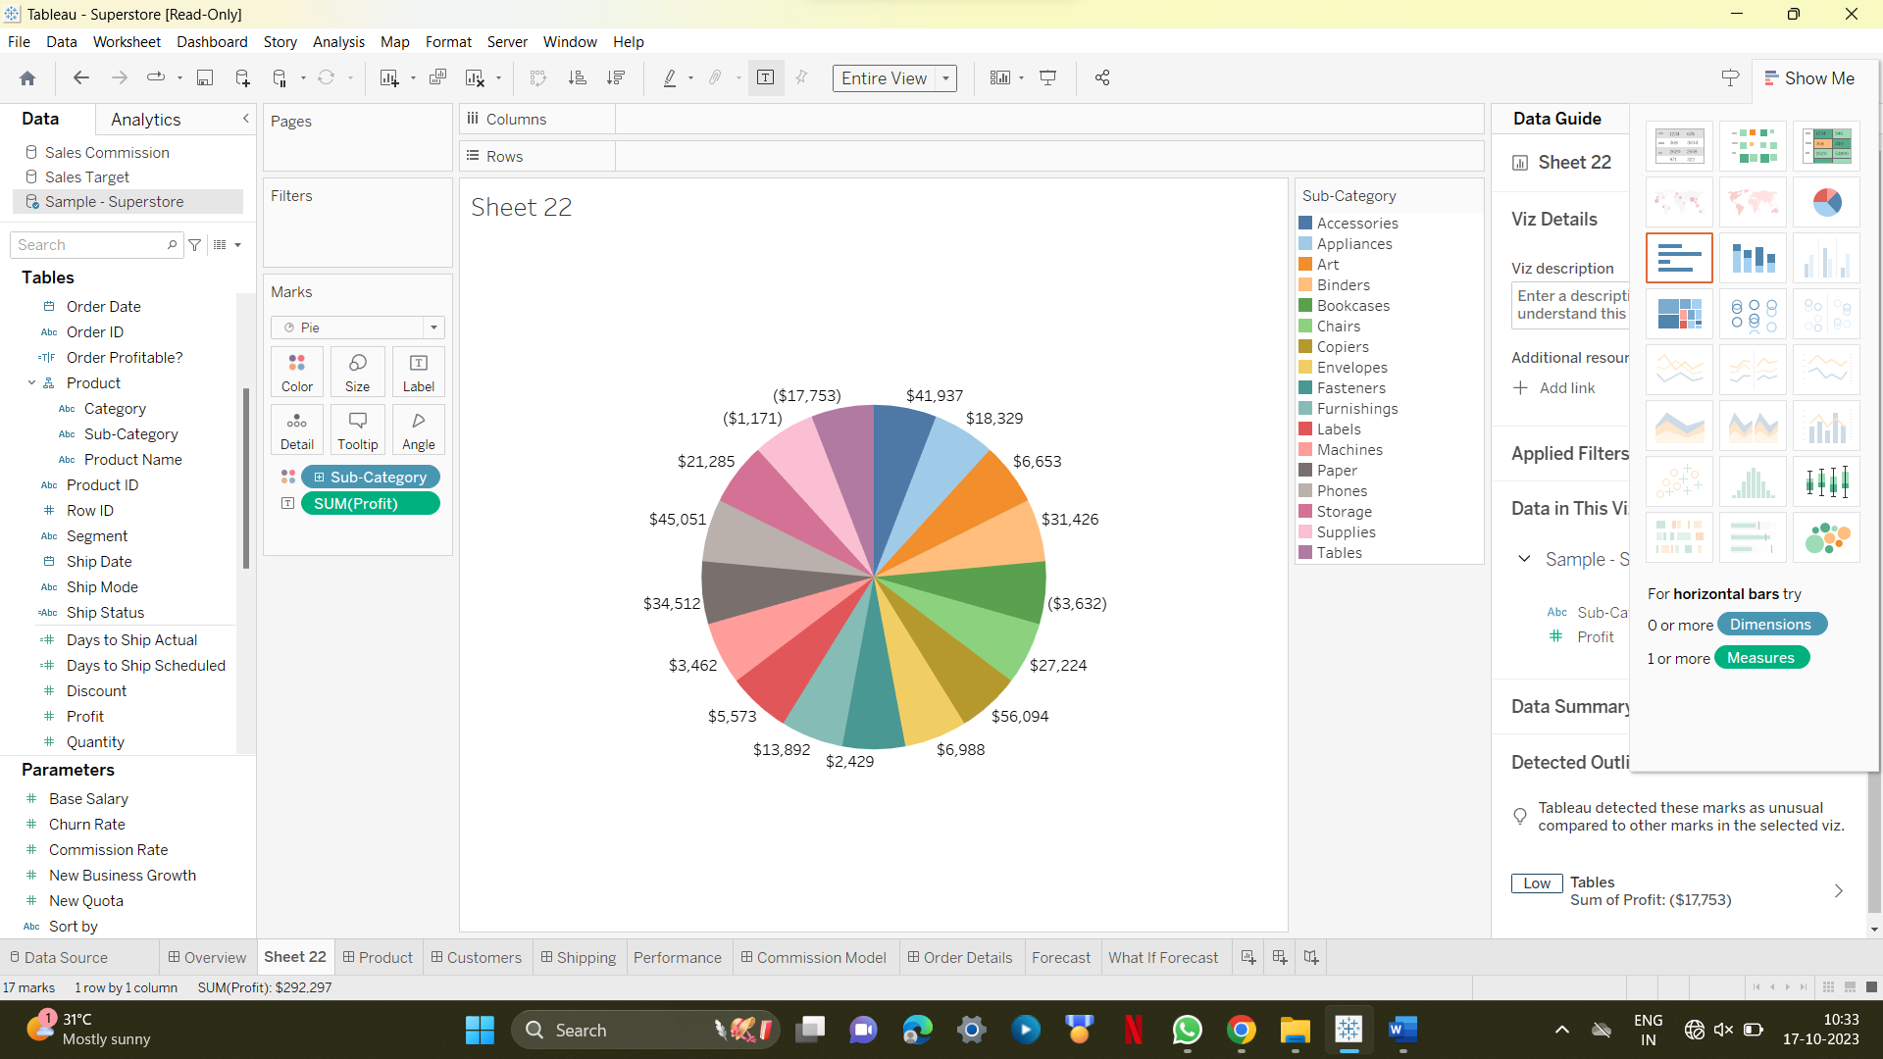

**4.(i)Tableau bubble chart** 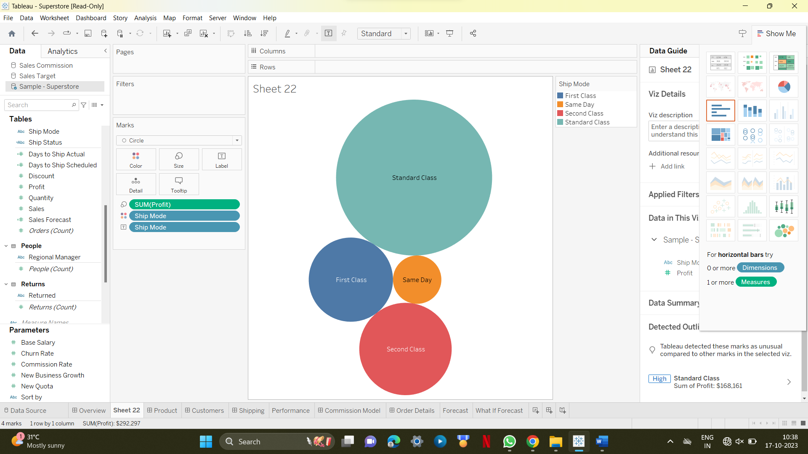

4.(ii)bubble chart with measure values 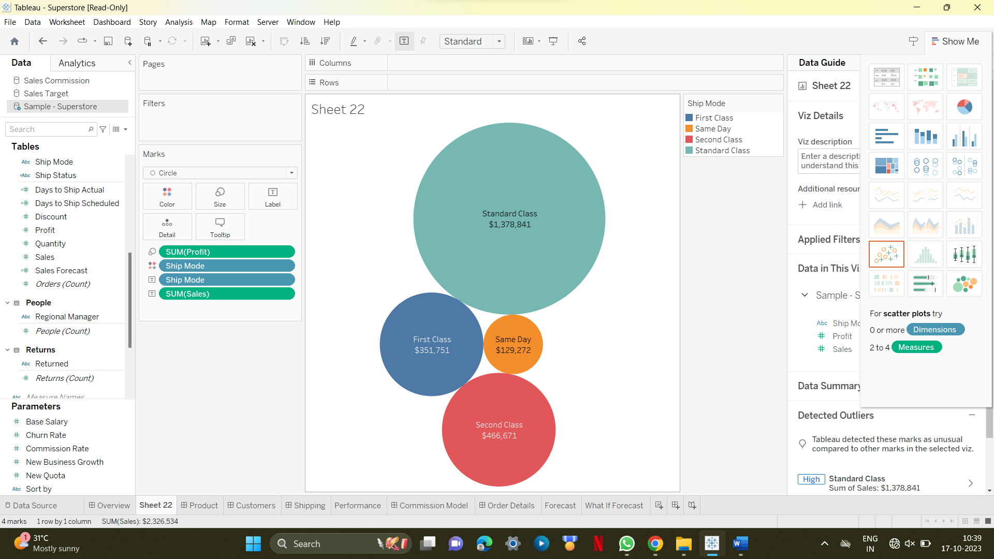

4.(iii)bubble chart with measure colors 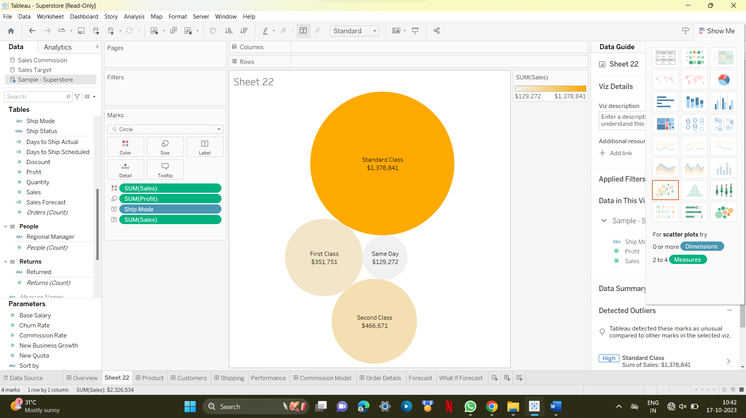

5.(i)Tableau box plot 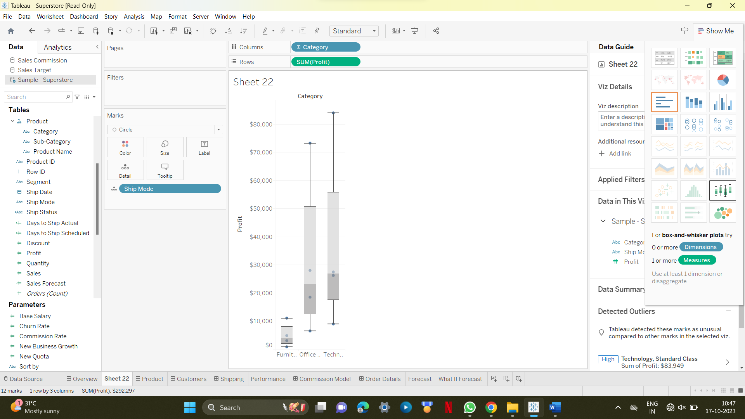

6.(i)Tableau heat map 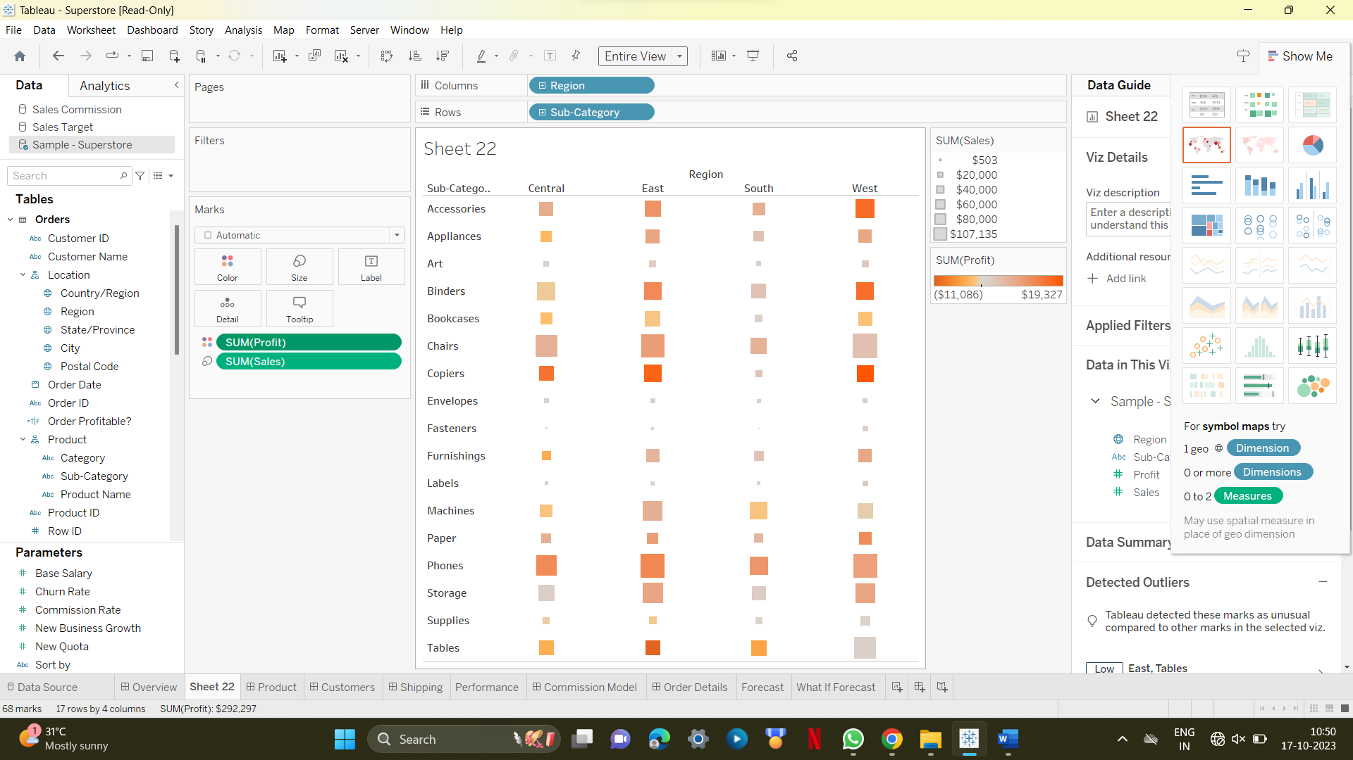

7.(i)Tableau tree maps 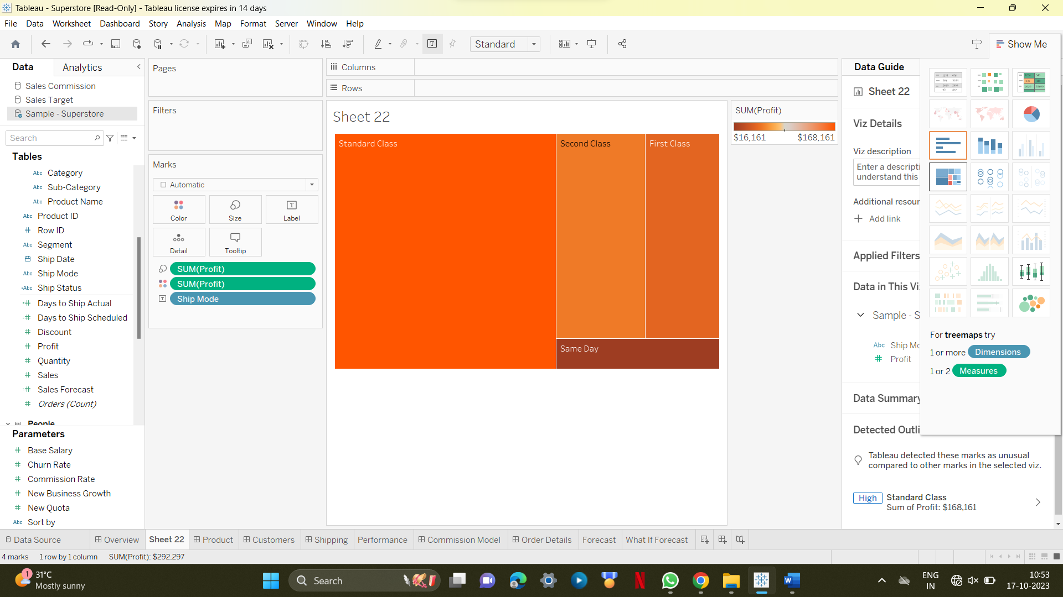

8.(i)Tableau scatter plot 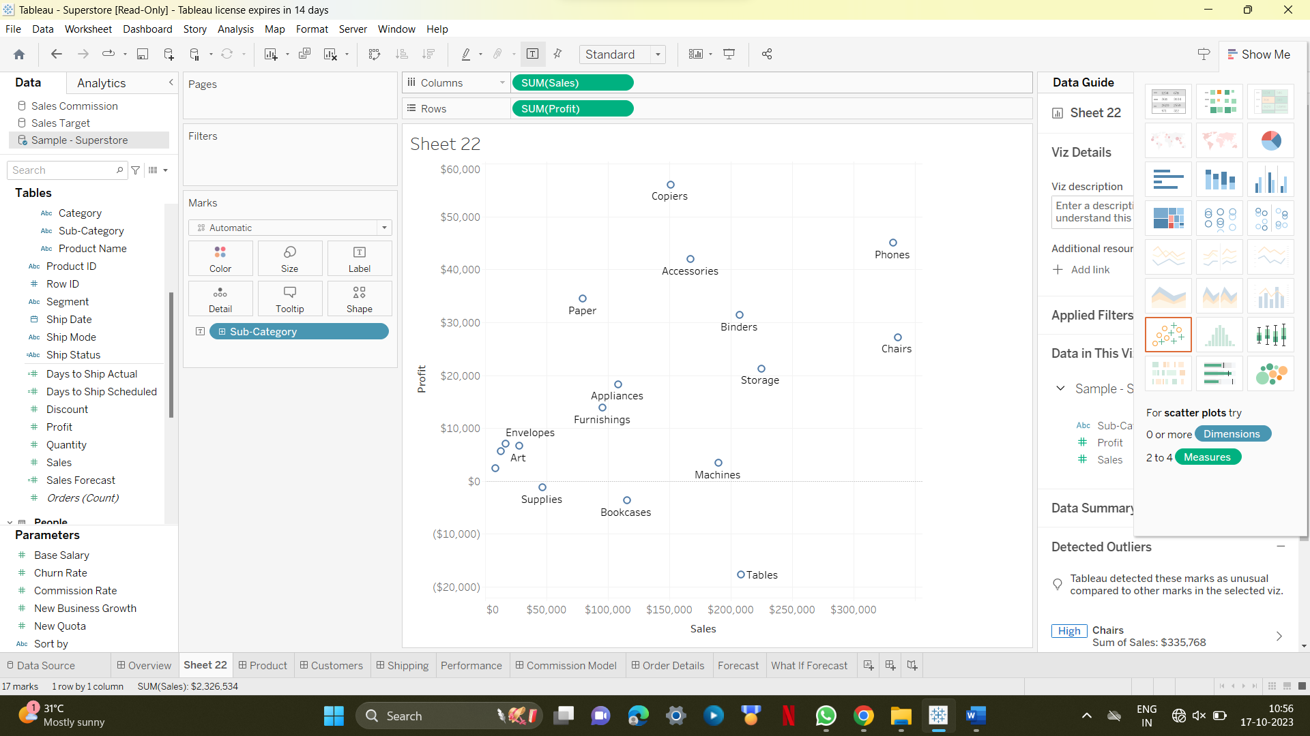

8.(ii)sactter plot with different colors 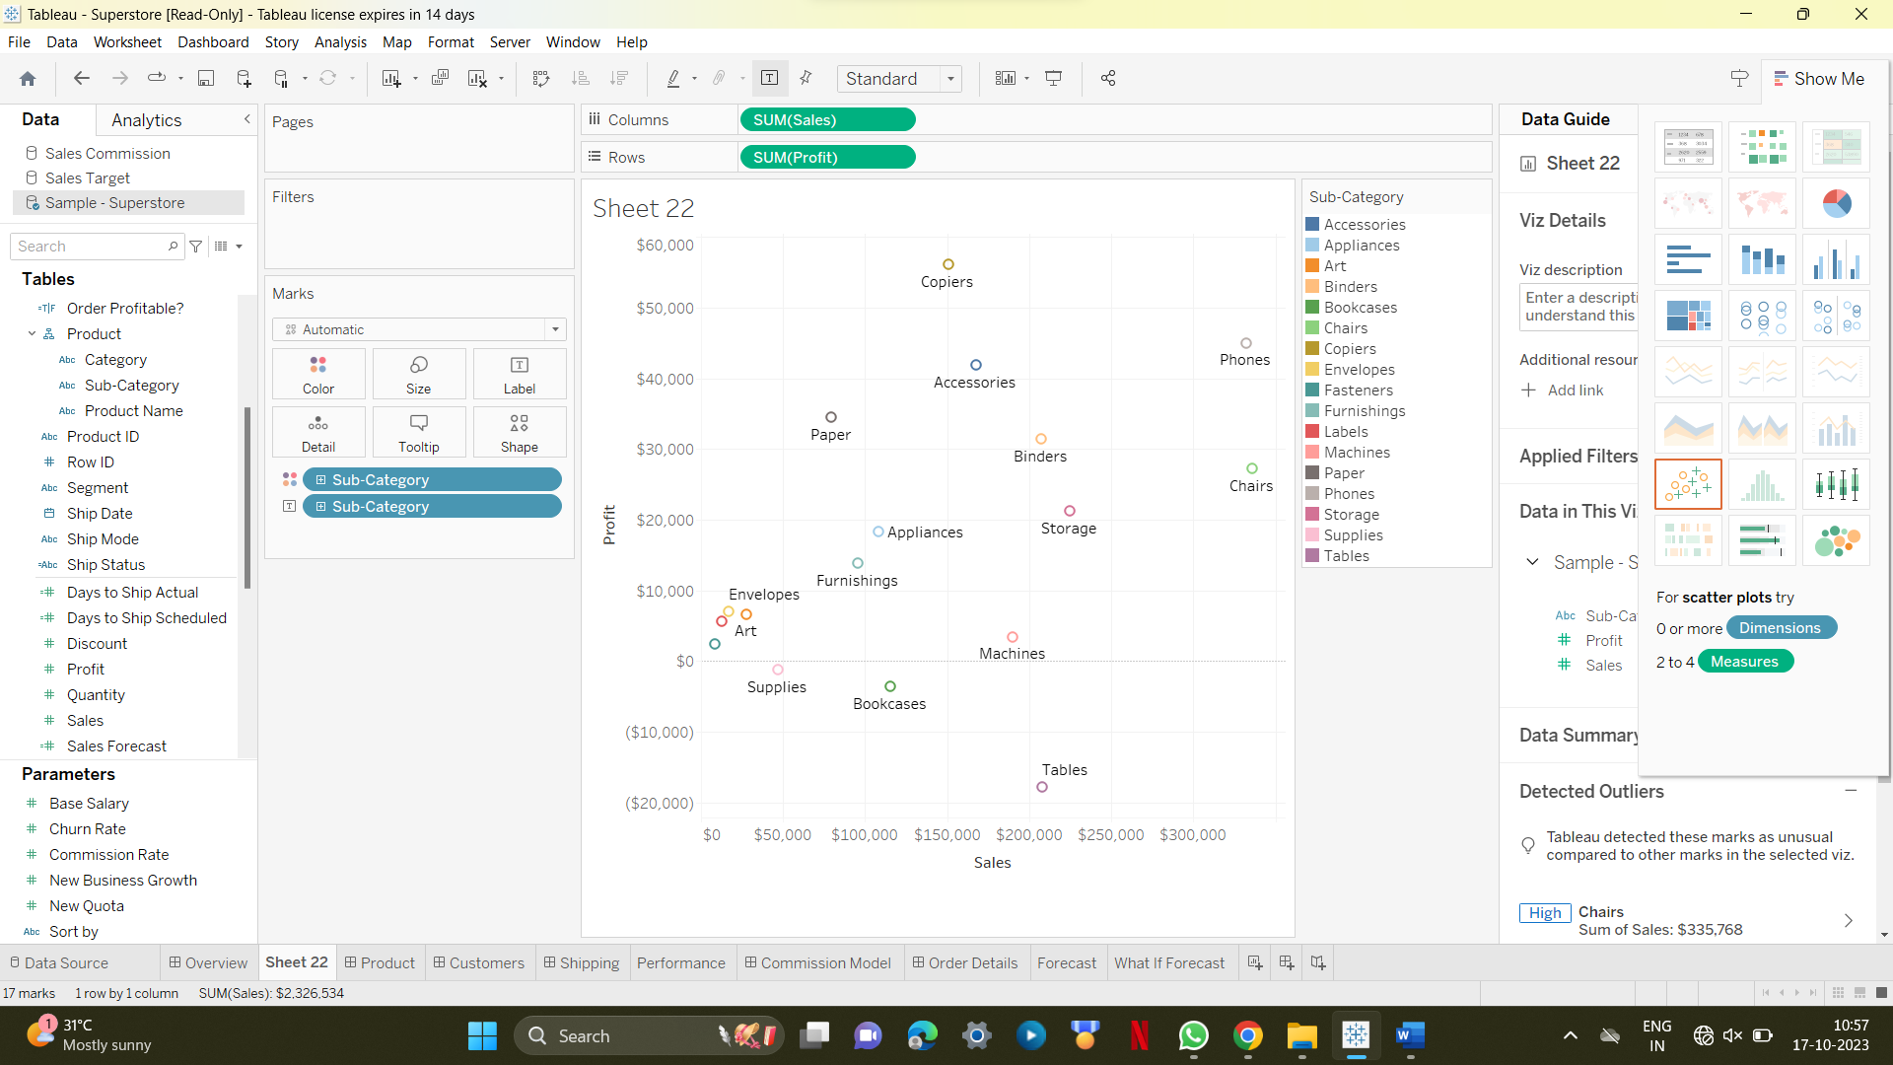

8.(iii)scatter plot with dimensions 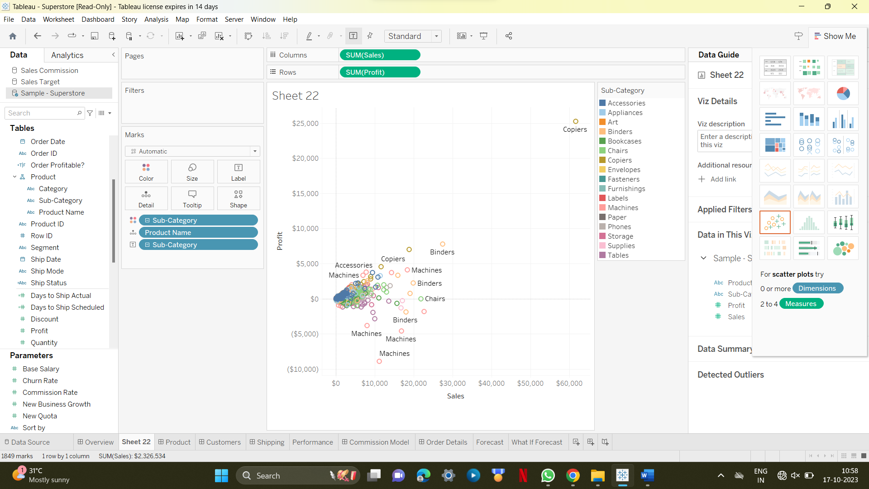

9.(i)Histogram 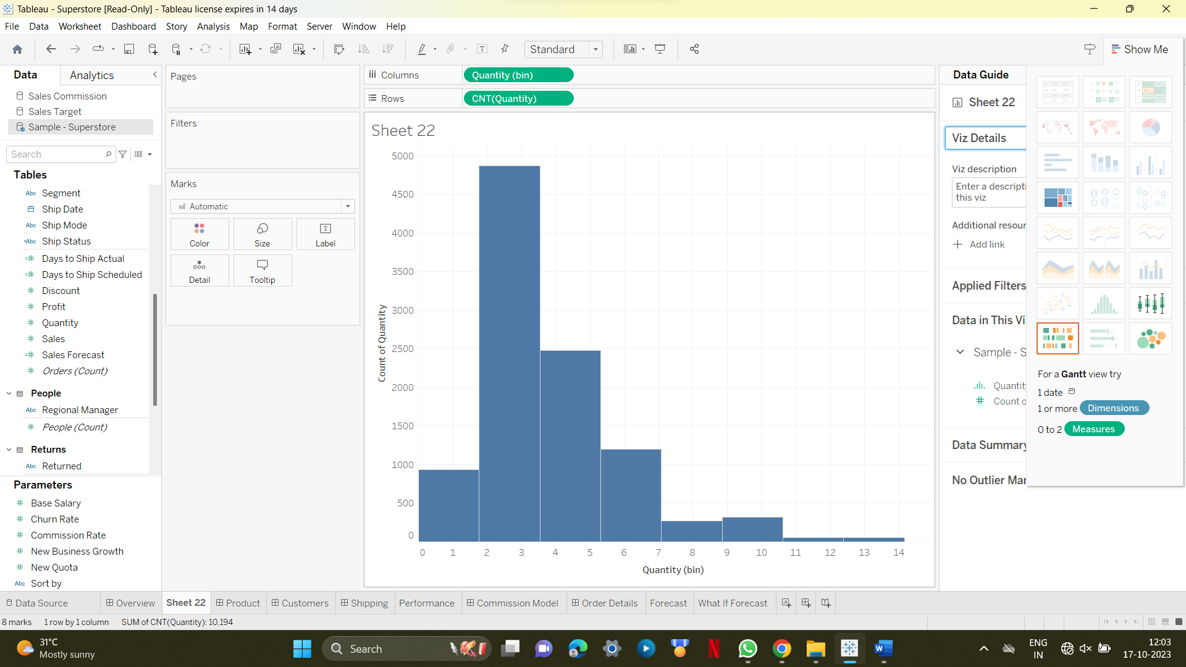

9(ii)histogram with percentage,color,percentage 